Press Release

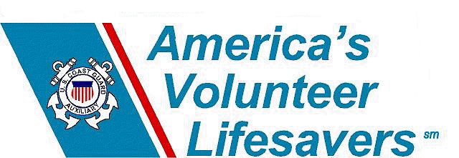
Date: April 14, 2006
Contact: Aux. Robert Westcott
Chief- External Communications
Public Affairs Department
United States Coast Guard Auxiliary
robwestcott@earthlink.net
http://www.auxpa.org
(386) 717-8437

LESSONS LEARNED: Better to “know before you go” when it comes to boating safety equipment and dealing with emergencies.

It was a warm summer afternoon on Memorial Day weekend. Folsom Lake, the most heavily used sole-state lake in California, located about 25 miles northeast from the capitol in Sacramento , was filled with boats of all types and sizes,

A young couple in their twenties, along with the woman’s brother, was enjoying a day of cruising and waterskiing on their older model inboard ski boat. It was just after lunch, and the husband attempted to start the engine and get underway again for more waterskiing in the remote north fork of the American River.

At first the engine didn’t turn over, and the boat was bouncing in the wakes of other boaters in the area. The boat’s ventilation system wasn’t working, and while the couple had intended to get it fixed, they didn’t have time to get it to the dealer before the busy holiday weekend began. They also haven’t had the engine services since they purchased the boat almost two years ago.

The husband continued to turn the key, when suddenly their was a loud pop, and smoke started coming form the engine compartment. The three boaters looked at each other, not knowing what to do, or exactly what the problem was. They soon began to sense the acrid smell of burning rubber, as the smoke began to increase from the engine compartment area.

The brother-in-law asked if they had a fire extinguisher on board, and the three began to search the compartments to locate the extinguisher. Once they located it, they actually didn’t know how to operate the extinguisher, and had to take a couple of minutes to read the directions. Once they learned what to do, they attempted to put out the small fire in the engine compartment, and they found out the hard way that their extinguisher had accidentally discharged while being stored under a seat cushion with a lot of other loose gear, and the extinguisher was fully discharged before the fire was completely out. At this point, none of the people on board were wearing life jackets.

Fortunately for the trio, a Good Samaritan in the area saw what was happening, and came by with another fire extinguisher to put out the small engine fire, and called the Coast Guard Auxiliary for further assistance.

This real life scenario described about is not limited to any specific type of craft or operator, or geographical location. Rather, it illustrates the need for boaters to be prepared for emergencies, and to be familiar with not only how to use their equipment, but to ensure that equipment is in good working order.

Let’s look at what went wrong in this case:
- The boat’s ventilation system was not working at all, and since the boat hadn’t been serviced in nearly two years, the engine’s backfire flame arrestor was dirty and contributed to the cause of the engine fire.
- The boaters didn’t know how to use their fire extinguisher, and weren’t exactly sure where it was located on board. Both of these factors cost precious time to be lost.
- None of the three boaters in this case were wearing life jackets, nor were any making preparations to abandon ship in the event the fire got further out of control. Moreover, since they were in a remote area, there was no cell phone coverage, and they had no marine radio on board.

There are two things the boaters in this case could have done to have prepared themselves for a situation like this:
- To “know before they go” they should have taken a boating safety course. It is a statistic that repeats itself over and over again: 80 percent of those individuals who die in boating accidents had never taken a boating safety class. In a boating safety class, they would have learned the importance of preventative maintenance, the dangers associated with a non-operations ventilation system, as well as how to deal with a fire on board their vessel.
- Furthermore, “to know before they go,” they could have had a free vessel safety check (VSC) performed by a qualified USCGAUX Vessel Examiner. During a VSC, the examiner reviews all the legally required items and equipment, as well as recommending some additional safety items.

If you want to follow the Coat Guard’s motto and be SEMPER PARATUS (always ready), we suggest you invest some time and take a boating safety course, and in getting a vessel safety check on your vessel before the boating season begins. To learn more about classes and the vessel safety check program, visit www.cgaux.org
The United States Coast Guard Auxiliary was founded in 1939 by an Act of Congress as the U.S. Coast Guard Reserve and re-designated as the Auxiliary in 1941. Its over 30,000 members donate millions of hours annually in support of Coast Guard missions.

- ### -

Credit release to Ed Sweeney DC-Ad Deputy Chief- USCGAUX Public Affairs

